Vertical Plane
# Source: AI Source: Provided by: [Data Path: Persons Table -> ID Column: 1, Name_En Column: Motasem Essam] -> From: [ChatGPT] on [7/25/2026]
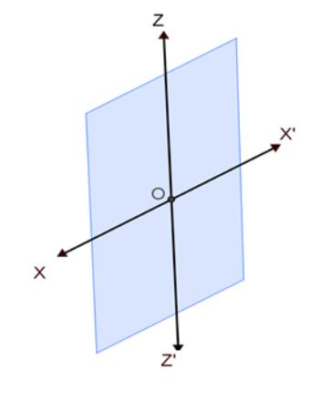
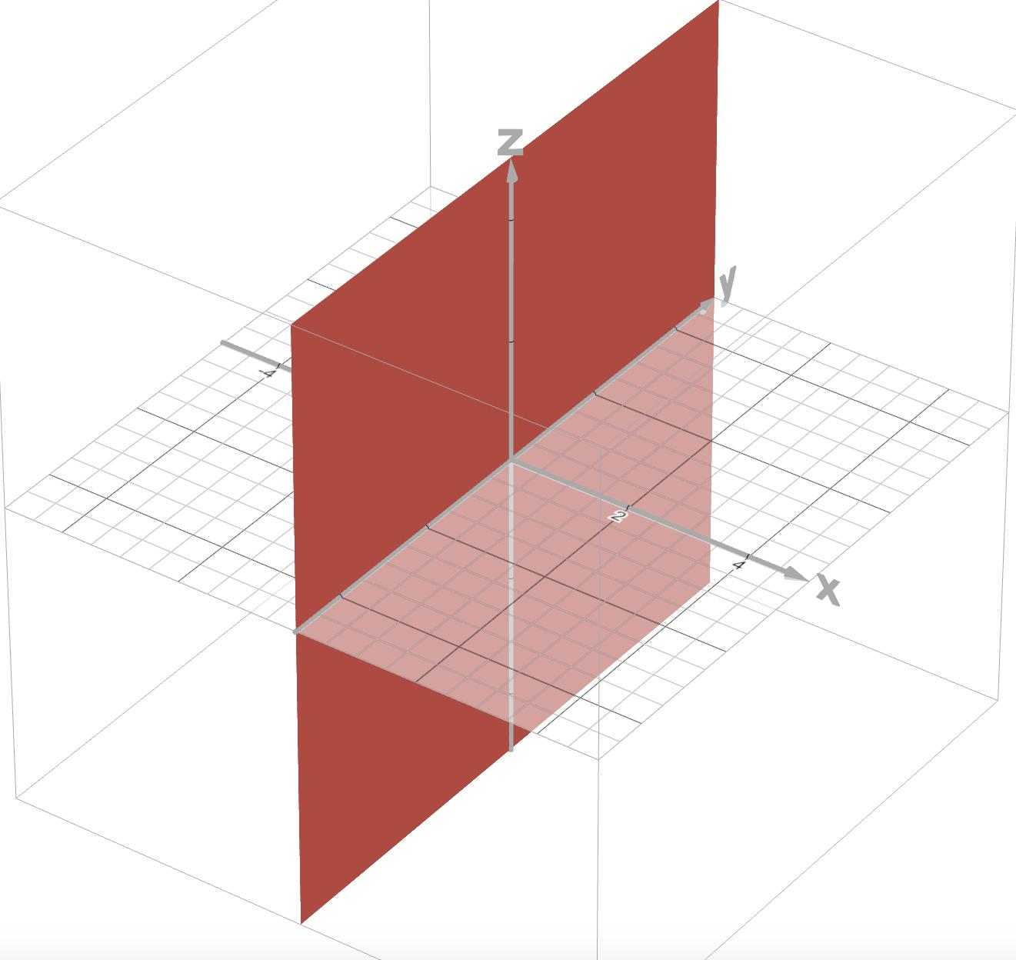
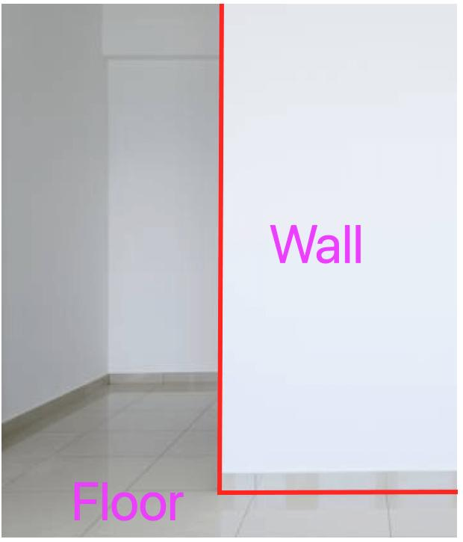
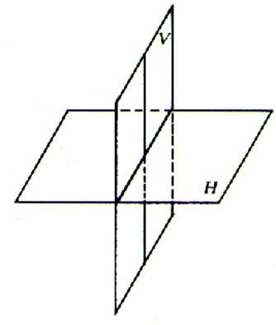
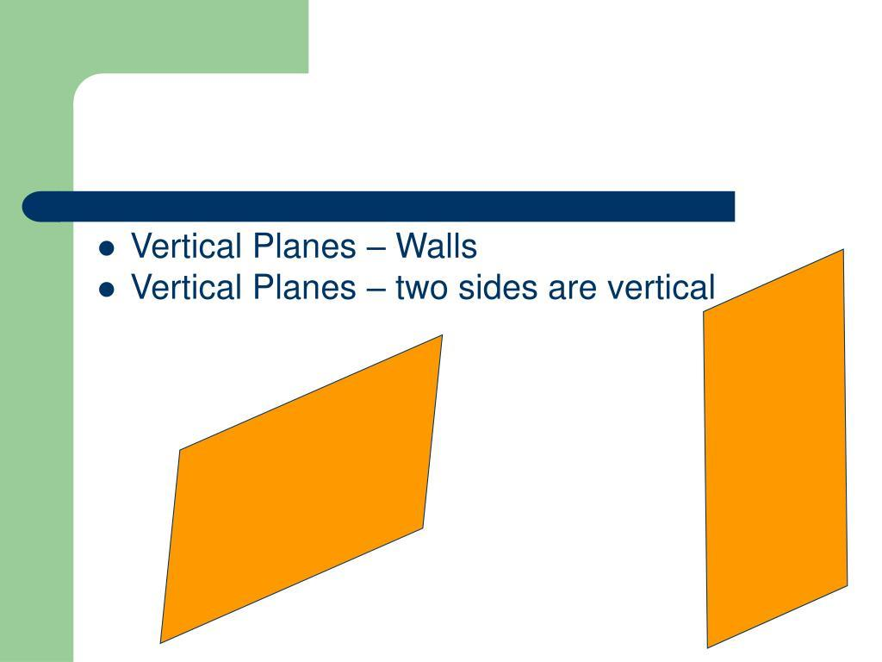
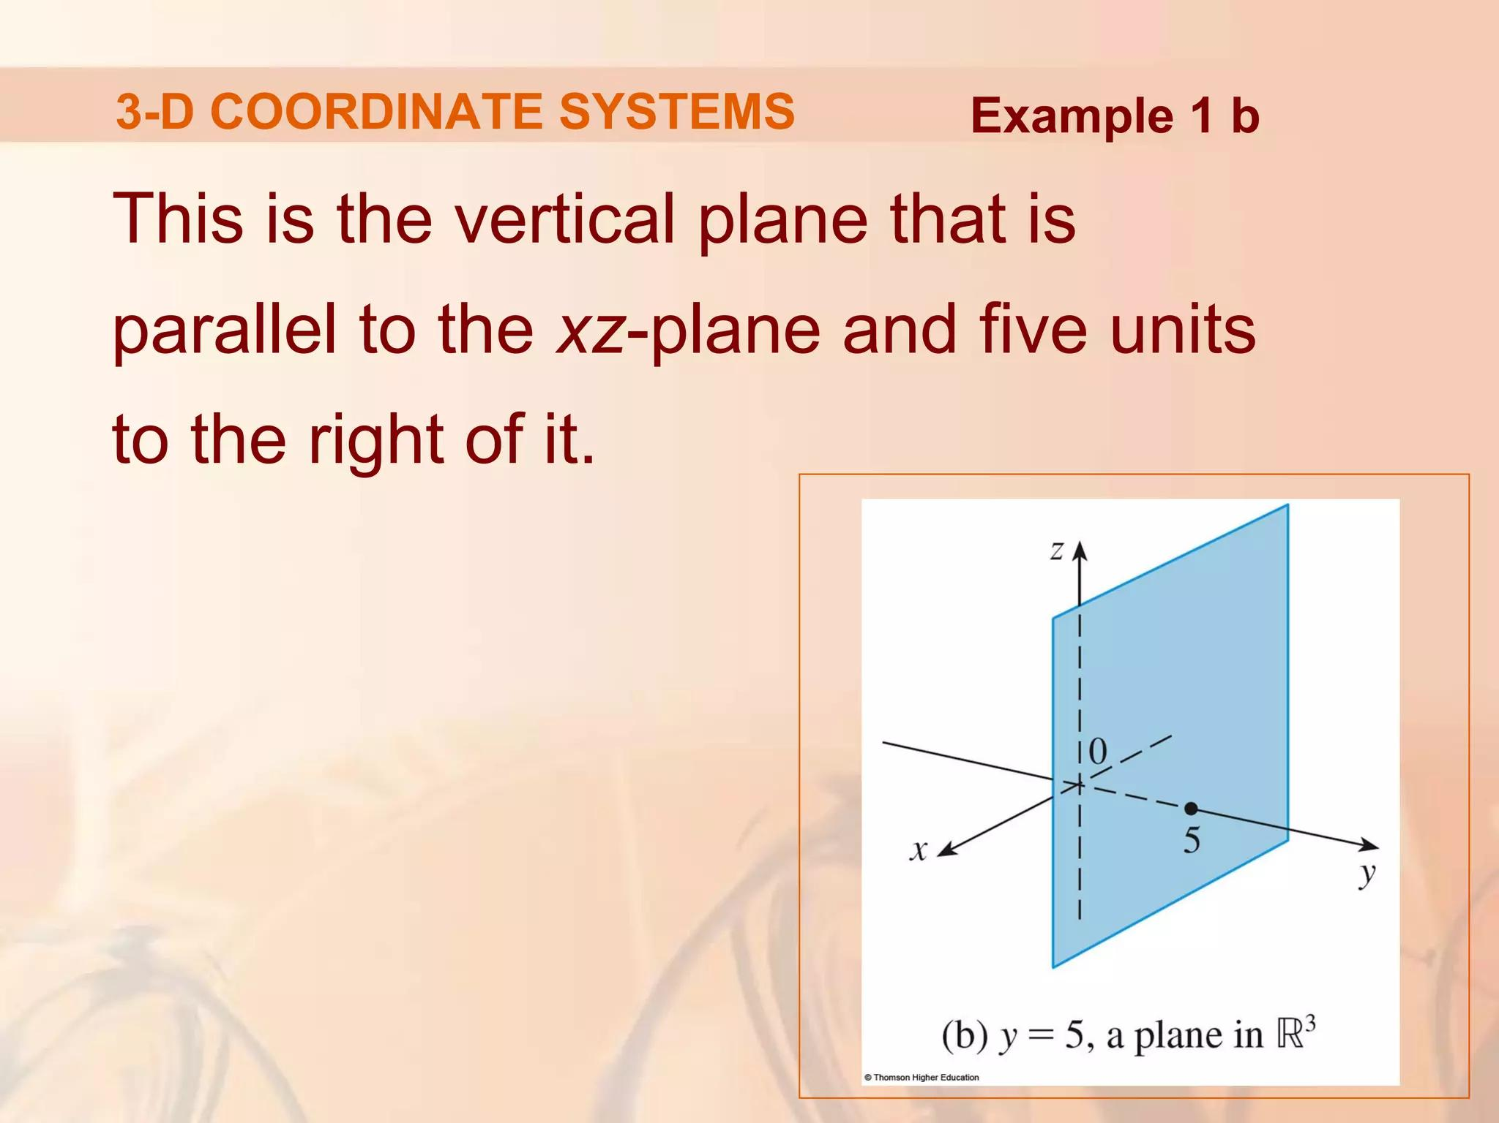

Definition
# Source: AI Source: Provided by: [Data Path: Persons Table -> ID Column: 1, Name_En Column: Motasem Essam] -> From: [ChatGPT] on [7/25/2026]
A Vertical Plane is a plane that is perpendicular to the horizontal plane and parallel to the direction of gravity. It extends infinitely in the vertical direction and in one horizontal direction.
In three-dimensional coordinate geometry, a vertical plane is characterized by an equation in which one horizontal coordinate is constant, such as:
$$x=c$$
or
$$y=c$$
where $c$ is a constant.

Characteristics
# Source: AI Source: Provided by: [Data Path: Persons Table -> ID Column: 1, Name_En Column: Motasem Essam] -> From: [ChatGPT] on [7/25/2026]
A vertical plane:
- Is perpendicular to the horizontal plane.
- Is parallel to the direction of gravity.
- Extends infinitely upward and downward.
- Extends infinitely in one horizontal direction.
- Divides space into two half-spaces.
- Contains infinitely many points and lines.

Illustration
# Source: AI Source: Provided by: [Data Path: Persons Table -> ID Column: 1, Name_En Column: Motasem Essam] -> From: [ChatGPT] on [7/25/2026]
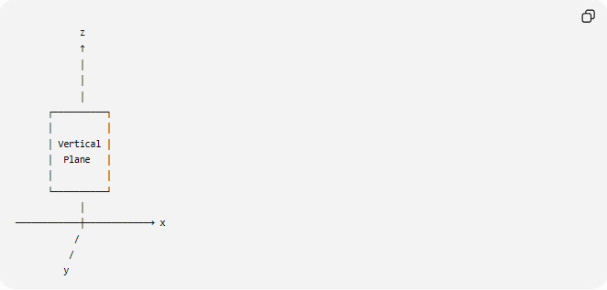
z
↑
│
│
│
┌──────────┐
│ │
│ Vertical │
│ Plane │
│ │
└──────────┘
│
────────────┼────────────→ x
/
/
y

Mathematical Representation
# Source: AI Source: Provided by: [Data Path: Persons Table -> ID Column: 1, Name_En Column: Motasem Essam] -> From: [ChatGPT] on [7/25/2026]
Plane Parallel to the $yz$-Plane
A vertical plane may be represented by:
$$x=c$$
where every point has the same $x$-coordinate.
Example:
$$x=4$$

Plane Parallel to the $xz$-Plane
Another vertical plane is:
$$y=c$$
Example:
$$y=-2$$

Position in the Coordinate System
# Source: AI Source: Provided by: [Data Path: Persons Table -> ID Column: 1, Name_En Column: Motasem Essam] -> From: [ChatGPT] on [7/25/2026]
In a three-dimensional Cartesian coordinate system:
- $x$-axis: horizontal
- $y$-axis: horizontal
- $z$-axis: vertical
A vertical plane always includes the vertical ((z)) direction.
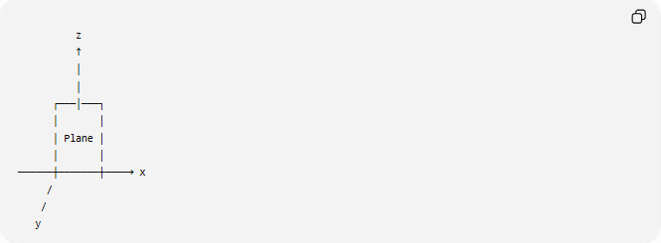
z
↑
│
│
┌───│───┐
│ │
│ Plane │
│ │
──────┼───────┼────→ x
/
/
y

Examples
# Source: AI Source: Provided by: [Data Path: Persons Table -> ID Column: 1, Name_En Column: Motasem Essam] -> From: [ChatGPT] on [7/25/2026]
Example 1
The equation:
$$x=0$$
represents the $yz$-plane, which is a vertical plane.

Example 2
The equation:
$$y=5$$
represents a vertical plane parallel to the $xz$-plane.

Example 3
Determine whether:
$$x=-3$$
is vertical.
Since the value of $x$ is constant:
$$\boxed{\text{It is a vertical plane.}}$$

Properties
# Source: AI Source: Provided by: [Data Path: Persons Table -> ID Column: 1, Name_En Column: Motasem Essam] -> From: [ChatGPT] on [7/25/2026]
1. Constant Horizontal Coordinate
For:
$$x=c$$
all points have the same $x$-coordinate.
For:
$$y=c$$
all points have the same $y$-coordinate.

2. Parallel to Gravity
A vertical plane contains the vertical direction.

3. Perpendicular to Horizontal Planes
A vertical plane intersects a horizontal plane at a right angle.

4. Infinite Extent
The plane extends infinitely in its two dimensions.

Real-World Examples
# Source: AI Source: Provided by: [Data Path: Persons Table -> ID Column: 1, Name_En Column: Motasem Essam] -> From: [ChatGPT] on [7/25/2026]
Vertical planes include:
- Walls.
- Doors.
- Windows.
- Billboards.
- Building facades.
- Elevator shafts.
- Cliff faces.
- Large upright screens.

Applications
# Source: AI Source: Provided by: [Data Path: Persons Table -> ID Column: 1, Name_En Column: Motasem Essam] -> From: [ChatGPT] on [7/25/2026]
Vertical planes are used in:
- Plane Geometry
- Coordinate Geometry
- Analytic Geometry
- Engineering
- Architecture
- Construction
- Surveying
- Navigation
- CAD (Computer-Aided Design)
- Computer Graphics
- Robotics
- Physics

Advantages
# Source: AI Source: Provided by: [Data Path: Persons Table -> ID Column: 1, Name_En Column: Motasem Essam] -> From: [ChatGPT] on [7/25/2026]
Studying vertical planes helps to:
- Describe upright structures.
- Model walls and partitions.
- Analyze three-dimensional objects.
- Define spatial orientation.
- Solve engineering and geometric problems.

Limitations
# Source: AI Source: Provided by: [Data Path: Persons Table -> ID Column: 1, Name_En Column: Motasem Essam] -> From: [ChatGPT] on [7/25/2026]
A vertical plane:
- Must remain perpendicular to the horizontal plane.
- Cannot be inclined.
- Is different from an oblique plane.
- Is represented by a constant horizontal coordinate.

Comparison with Other Plane Types
# Source: AI Source: Provided by: [Data Path: Persons Table -> ID Column: 1, Name_En Column: Motasem Essam] -> From: [ChatGPT] on [7/25/2026]
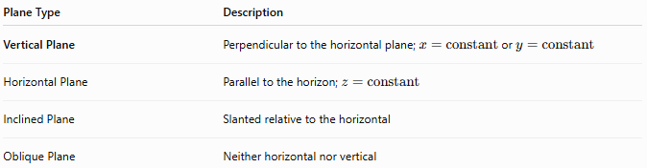
Plane Type | Description
Vertical Plane | Perpendicular to the horizontal plane; $x=\text{constant}$ or $y=\text{constant}$
Horizontal Plane | Parallel to the horizon; $z=\text{constant}$
Inclined Plane | Slanted relative to the horizontal
Oblique Plane | Neither horizontal nor vertical

Key Points
# Source: AI Source: Provided by: [Data Path: Persons Table -> ID Column: 1, Name_En Column: Motasem Essam] -> From: [ChatGPT] on [7/25/2026]
- A Vertical Plane is perpendicular to the horizontal plane.
- Standard equations include:
$$x=c$$
or
$$y=c$$
- The $yz$-plane is:
$$x=0$$
- The $xz$-plane is:
$$y=0$$
- Vertical planes are widely used to model upright structures and define spatial relationships.

Conclusion
# Source: AI Source: Provided by: [Data Path: Persons Table -> ID Column: 1, Name_En Column: Motasem Essam] -> From: [ChatGPT] on [7/25/2026]
A Vertical Plane is an upright plane that is perpendicular to the horizontal plane and parallel to the direction of gravity. In coordinate geometry, it is commonly represented by equations such as $x=c$ or $y=c$, where one horizontal coordinate remains constant. Vertical planes are fundamental in analytic geometry, engineering, architecture, construction, surveying, navigation, CAD, robotics, physics, and computer graphics, where they are used to describe walls, partitions, elevations, and other upright structures in three-dimensional space.

